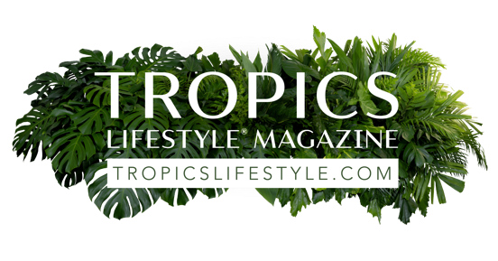

Lisa A. Bastian, Editor & Publisher

Award-winning business communicator Lisa Bastian is co-owner of Palm Life Publishing LLC, the company producing [Tropics Lifestyle](https://magazine.tropicslifestyle.com/) digital magazine, [TropicsLifestyle.com](https://www.tropicslifestyle.com/) website, [Tropics Lifestyle Podcast](https://www.tropicslifestylepodcast.com/), Tropics Lifestyle Designer Directory, and other products.

As the Editor and Publisher of Tropics Lifestyle, Lisa is responsible for all of the magazine’s editorial and promotional content, and oversees the entire production process. She also is the host of our new podcast which brings an exciting audio dimension to our stories promoting the love of a beautiful home and garden lifestyle influenced by the beach, ocean and rainforest.

During the pandemic, Lisa established [Tropics Lifestyle](https://magazine.tropicslifestyle.com/) to spread some joy in a frazzled world through well-crafted stories supporting a tropics lifestyle for everyone, no matter where they live on Earth. Her classy mother Elizabeth Steinker, who decorates in a coastal style in Ohio, inspired the creation of the magazine

​

Lisa also founded and owns [Bastian Public Relations](https://www.bastianpr.com/), a boutique agency serving diverse industries, most notably as a publication partner and social media manager. She draws upon three decades of providing editorial, marketing and PR services for her coastal adventure empire bringing happiness to readers (and listeners) from around the world.

To share questions or comments with Lisa, please call her at 760-876-7426 (Central time) or email [Editor@tropicslifestyle.com](mailto:editor@tropicslifestyle.com?subject=*%20I%20have%20a%20question%20or%20comment%20for%20Lisa%20Bastian%20of%20Tropics%20Lifestyle).

​